Janardhana Reddy M S
Jr6922
N12832723

Question 1) a)

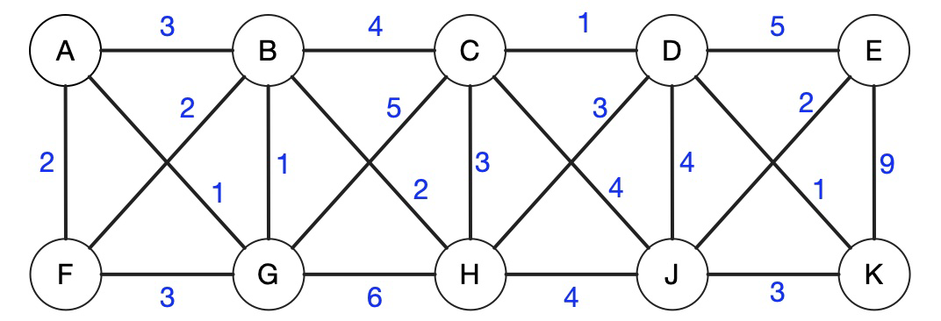
Priority Queue (Vertex, priority, weight);

Initially:
A: 0 (because we are starting here)
B: infinity
C: infinity
D: infinity
E: infinity
F: infinity
G: infinity
H: infinity
J: infinity
K: infinity

Parent table:
A: None
B: None
C: None
D: None
E: None
F: None
G: None
H: None
J: None
K: None

Step1 :
We will Expand neighbors of A:
A ->B (3), B updated to 3, parent B = A
A -> F (2) , F updated to 2, parent F = A
A -> G (1) , G updated to 1, parent G = A
New priority Queue:
B: 3 ,C: Infinity ,D: Infinity, E: Infinity F: 2, G: 1 ,H: Infinity, J: Infinity ,K: Infinity
New parent a table:
A: None, B: A ,C: None, D: None ,E: None ,F: A ,G: A, H: None ,J: None, K: None

Step 2: Pick G (priority 1)
Expand neighbors of G:
- G ->B (1) -> 1 < 3 : B updated to 1, parent B = G
- G ->C (5) -> C updated to 5, parent C = G
- G -> H (6) -> H updated to 6, parent H = G
New priority Queue:
B: 1, C: 5, D: Infinity, E: Infinity , F: 2 , H: 6, J: Infinity , K: Infinity
New parent table:
A: None, B: G, C: G , D: None , E: None , F: A , G: A , H: G , J: None , K: None

Step 3: Pick B (priority 1)
Expand neighbors of B:
- B -> C (4) 4 < 5 -> C updated to 4, parent C = B
- B -> H(2). 2<5, then H is now updated to 2, parent of H = B
New Priority Queue:
C: 4 , D: Infinity, E: Infinity, F: 2 , H: 2, J : Infinity, K: Infinity
New Parent table:
A: None , B: G , C: B , D: None , E: None , F: A , G: A , H: B , J: None , K: None

Step 4: Pick F (priority 2)
Expand neighbors of F:
- F No better updates to any nodes.
New Priority Queue:
C: 4 , D: Infinity, E: Infinity , H: 2, J : Infinity, K: Infinity
Parent table:
Same

Step 5: Pick H (priority 2)
Expand neighbors of H:
- H -> C (3) , 3 < 4 -> C updated to 3, parent C = H
- H -> D (3) , D updated to 3, parent D = H
- H -> J (4) , J updated to 4, parent J = H

New Priority Queue:
C: 3, D: 3, E: Infinity, J : 4 , K: Infinity
New Parent table:
A: None , B: G , C: H , D: H , E: None , F: A , G: A , H: B , J: H , K: None

Step 6:
We pick C, now 1<3 , so we update D to 1. Then parent of D = C
New Priority Queue:
D: 1, E: Infinity, J : 4 , K: Infinity
New Parent table:
A: None , B: G , C: H , D: C , E: None , F: A , G: A , H: B , J: H , K: None

Step 7:
We pick D, priority =1.
D-> E, 5, then E= 5, parent of E =. D
D-> K = 1, then k = 1, parent of K. =. D
New Priority Queue:
E: 5, J : 4 , K: 1
New Parent table:
A: None , B: G , C: H , D: C , E: D , F: A , G: A , H: B , J: H , K: D

Step 8:
Pick k, priority = 1
d->j is 3, 3<4, then update j=3 , parent of J = K
New Priority Queue:
E: 5, J : 3

New Parent table:
A: None , B: G , C: H , D: C , E: D , F: A , G: A , H: B , J: K , K: D

Step 9:
Pick J:
Then for J-> E : 2, then update parent of E = E
New Priority Queue:
E: 2
New Parent table:
A: None , B: G , C: H , D: C , E: J , F: A , G: A , H: B , J: K , K: D

Step 10:
Pick E
Priority Queue:
Same
Parent Table:
Same

Total weight of MST I get solving using prims is : 16

Question 1)b)
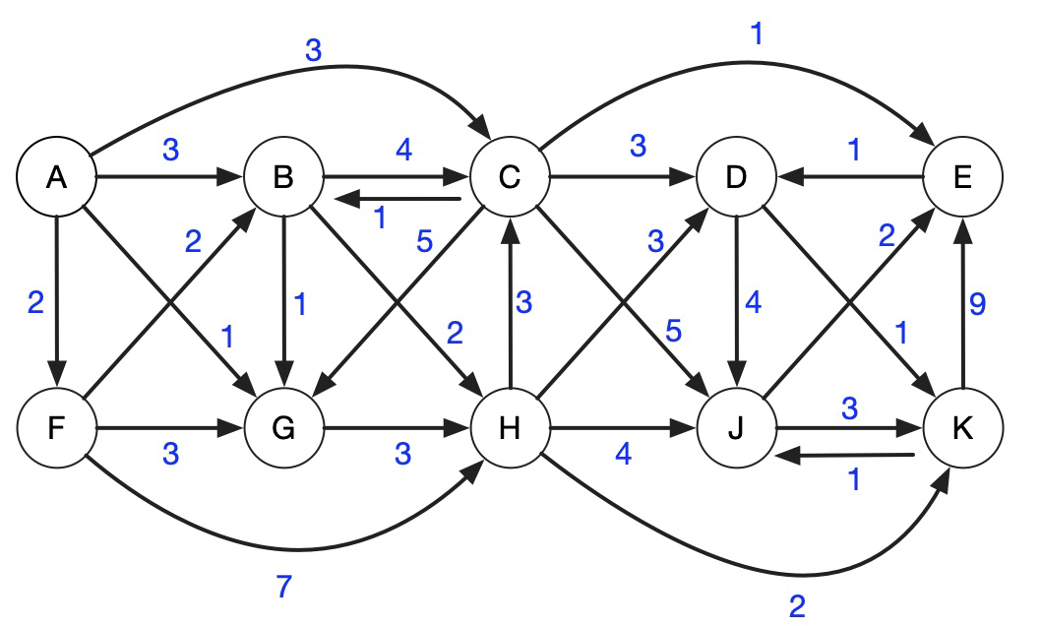
Initially
Node |  | S D | Parent
A |  | 0 | None
B |  | Inf | None
C |  | inf | None
D |  | inf | None
E |  | inf | None
F |  | inf | None
G |  | inf | None
H |  | inf | None
J |  | inf | None
 | K | inf | None

Step 1:
Let’s start from vertex A:
B (3) : distance to B = 0 + 3 = 3 : Update B (parent A)
C (3) : distance to C = 0 + 3 = 3 : Update C (parent A)
F (2) : distance to F = 0 + 2 = 2 : Update F (parent A)
G (1) : distance to G = 0 + 1 = 1 : Update G (parent A)

Node |  | S D | Parent
A |  | 0 | None
B |  | 3 | A
C |  | 3 | A
D |  | inf | None
E |  | inf | None
F |  | 2 | A
G |  | 1 | A
H |  | inf | None
J |  | inf | None
 | K | inf | None

Step 2:
The minimum distance here is for node G:
Then lets pick G:
It has one neighbour, H : 3, 1+3 = 4, update H= 4, parent of H = G

Node | S D | Parent
A | 0 | None
B | 3 | A
C | 3 | A
D | inf | None
E | inf | None
F | 2 | A
G | 1 | A
H | 4 | G
J | inf | None
K | inf | None

Step 3:
The minimum now is F, lets pick F;
It has neighbours B, G, and H, then
B : 2, current distance to B = 3, new possible distance = 2 + 2 = 4 : No update (3 is better)
G : 3 : already visited
H : 7 : current distance to H = 4, new possible = 2 + 7 = 9 : No update (4 is better)
Node | S D | Parent
A | 0 | None
B | 3 | A
C | 3 | A
D | inf | None
E | inf | None
F | 2 | A
G | 1 | A
H | 4 | G
J | inf | None
K | inf | None

Step 4:
Lets pick B, which is currently with minimum distance,
Its neighbors are, C, G and H
C : 4: current distance to C = 3, new possible = 3 + 4 = 7 : No update (3 is better)
G : 1 : already visited
H : 2 : distance to H = 3 + 2 = 5 : H already has 4 (better), so no update
Node | S D | Parent
A | 0 | None
B | 3 | A
C | 3 | A
D | inf | None
E | inf | None
F | 2 | A
G | 1 | A
H | 4 | G
J | inf | None
K | inf | None

Step 5:
Lets pick C, then it has 5 neighbors, B, D, G, J and E
D (3) : distance to D = 3 + 3 = 6 : Update D (parent C)
E (1) : distance to E = 3 + 1 = 4 : Update E (parent C)
G (5) : already visited
J (5) : distance to J = 3 + 5 = 8 : Update J (parent C)
B (1) : But already visited,
Node | S D | Parent
A | 0 | None
B | 3 | A
C | 3 | A
D | 6 | C
E | 4 | C
F | 2 | A
G | 1 | A
H | 4 | G
J | 8 | C
K | inf | None

Step 6:
Lets take H, distance of 4, it has 4 neighbors,
C (3) ->already visited
D (3) ->current distance to D = 6, new possible = 4 + 3 = 7 ->No update (6 is better)
J (4) ->current distance to J = 8, new possible = 4 + 4 = 8 ->no better
K (2) ->distance to K = 4 + 2 = 6 ->Update K (parent H)
Node | S D | Parent
A | 0 | None
B | 3 | A
C | 3 | A
D | 6 | C
E | 4 | C
F | 2 | A
G | 1 | A
H | 4 | G
J | 8 | C
K | 6 | H

Step 7:
Pick E: it has 1 neighbour
D : 1 , distance to D = 4 + 1 = 5 ->Update D (parent E)
Node | S D | Parent
A | 0 | None
B | 3 | A
C | 3 | A
D | 5 | E
E | 4 | C
F | 2 | A
G | 1 | A
H | 4 | G
J | 8 | C
K | 6 | H

Step 8:
Pick D, distance = 5
It has two neighbors. J and k
distance to J = 5 + 4 = 9 ->current J = 8, so no update
K (1) ->distance to K = 5 + 1 = 6 (already 6) ->no better
Node | S D | Parent
A | 0 | None
B | 3 | A
C | 3 | A
D | 5 | E
E | 4 | C
F | 2 | A
G | 1 | A
H | 4 | G
J | 8 | C
K | 6 | H

Step 9:
Lets pick K, It has two neighbors, E and J
E (9) ->already visited
J (3) ->distance to J = 6 + 3 = 9, no better
Node | S D | Parent
A | 0 | None
B | 3 | A
C | 3 | A
D | 5 | E
E | 4 | C
F | 2 | A
G | 1 | A
H | 4 | G
J | 8 | C
K | 6 | H

Step 10:
Pick J, Final node:
Two neighbors , E and K, already visited.
Node | S D | Parent
A | 0 | None
B | 3 | A
C | 3 | A
D | 5 | E
E | 4 | C
F | 2 | A
G | 1 | A
H | 4 | G
J | 8 | C
K | 6 | H

The table has final distance to reach the node from A and the parent along the path.

Question 1) c):
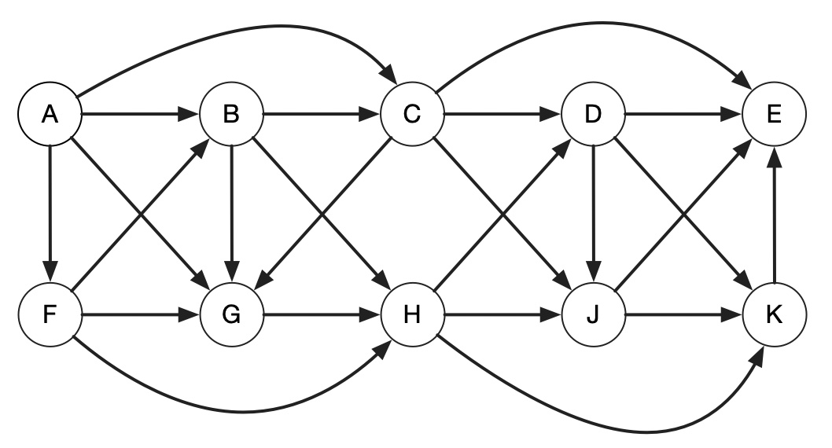
We use DFS to find the topological sorting order here, We start with vertex A. I am first preparing an adjacency list for this graph:
- A ->B, C, F, G
- B ->C, G, H
- C ->D, E, G, J
- D ->E, J, K
- E ->(nothing)
- F ->B, G, H
- G ->H
- H ->D, J, K
- J ->E
- K ->E

We start from :
Time (t) = 0
Parent(u) = None
Visited = false for all nodes
All the vertices are initially not visited.

Step 1:
Start by visiting A:
T = 1, start(A) = 1, visited(a) = True
Now, from unvisited neighbors of A, we take B

Step 2:
Visit B:
T = 2, start B = 2, Visited(b) = True
Now from unvisited neighbors of B, We can take C.

Step 3:
Visit C:
T=3, start C = 3. Visited(c ) = True
Now from not visited neighbors of C, take D

Step 4:
Visit D:
T=4, start D = 4. Visited(d ) = True
Now from not visited neighbors of D, take E

Step 5:
Visit E:
T=5, start E = 5. Visited(e ) = True
Now from not visited neighbors of E, we have none. The finish time of E = 6
Return to D.

Step 6:
From other unvisited neighbors of D, we take J.
Start time. = 7, visited(j) = True.
Now from unvisited neighbors of J, we take K
Step 7:
Visit K,
Start time = 8, visited (k) = True
Now unvisited neighbors of K =. None , since E is already visited.
Finish time of K = 9,

Step 8:
No unvisited neighbors of J left, Then finish time of J = 10,
Move back to D.

Step 10:
No unvisited neighbors for D left, Then finish of D =11
Move back to C

Step 11:
C has G as unvisited neighbors, then
Start of G = 12, visited of G = True

Step 12:
At g, we have H as unvisited neighbor, then
Start of H = 13, time = 13, all neighbors of H are visited, So
Finish time of H = 14,
Move back to G

Step 13:
At G, all neighbors are visited, so
Finish of G = 15, move back to C

Step 14:
At C, all neighbors are visited, so
Finish of C = 16, move back to B

Step 15:
All neighbors of B are visited, so
Finish of B = 17, move back to A

Step 16:
A still has F as a neighbor which is not visited, then
Start of F = 18

Step 17:
All neighbors of F are visited, then
Finish of F = 19, move back to A

Step 18:
All neighbors of A are visited, then, finish of A = 20
Now, all the nodes are finished.
Node | Start Time | Finish Time
A | 1 | 20
B | 2 | 17
C | 3 | 16
D | 4 | 11
E | 5 | 6
F | 18 | 19
G | 12 | 15
H | 13 | 14
J | 7 | 10
K | 8 | 9

Ordering nodes by finish time:
A ->F ->B ->C ->G ->H ->D ->J ->K ->E
DFS Trace Tree:
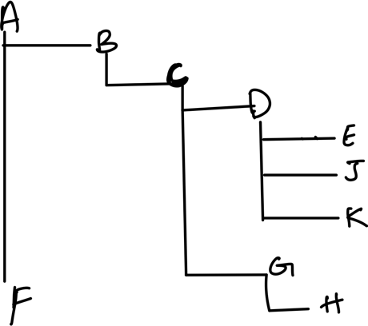

Question 1) d):
Strongly Connected Components is when , for a pair of nodes, there is edge from both directions.
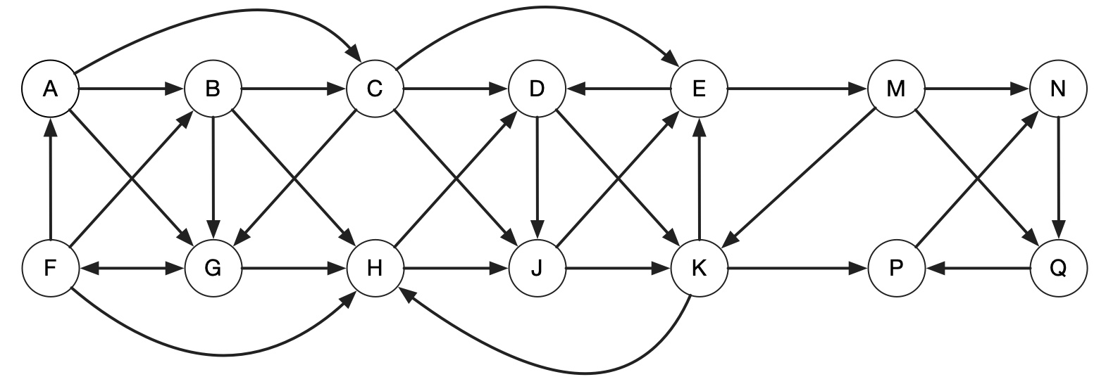
I am not showing, all the steps involved in DFS here, I am showing the final table that contains start, finish times and nodes, I have followed the steps I have taken in previous question to solve this.
Node | Start | Finish
A | 1 | 28
B | 2 | 27
C | 3 | 26
D | 4 | 21
E | 6 | 19
F | 23 | 24
G | 22 | 25
H | 15 | 16
J | 5 | 20
K | 14 | 17
M | 7 | 18
N | 8 | 13
P | 10 | 11
Q | 9 | 12

Next step in SCC algorithm, We do transpose the adjacency matrix, or reverse the edge direction I graph,
Order:
A (28), B (27), C (26), G (25), F (24), D (21), J (20), E (19), M (18), K (17), H (16), N (13), Q (12), P (11)

The graph for that,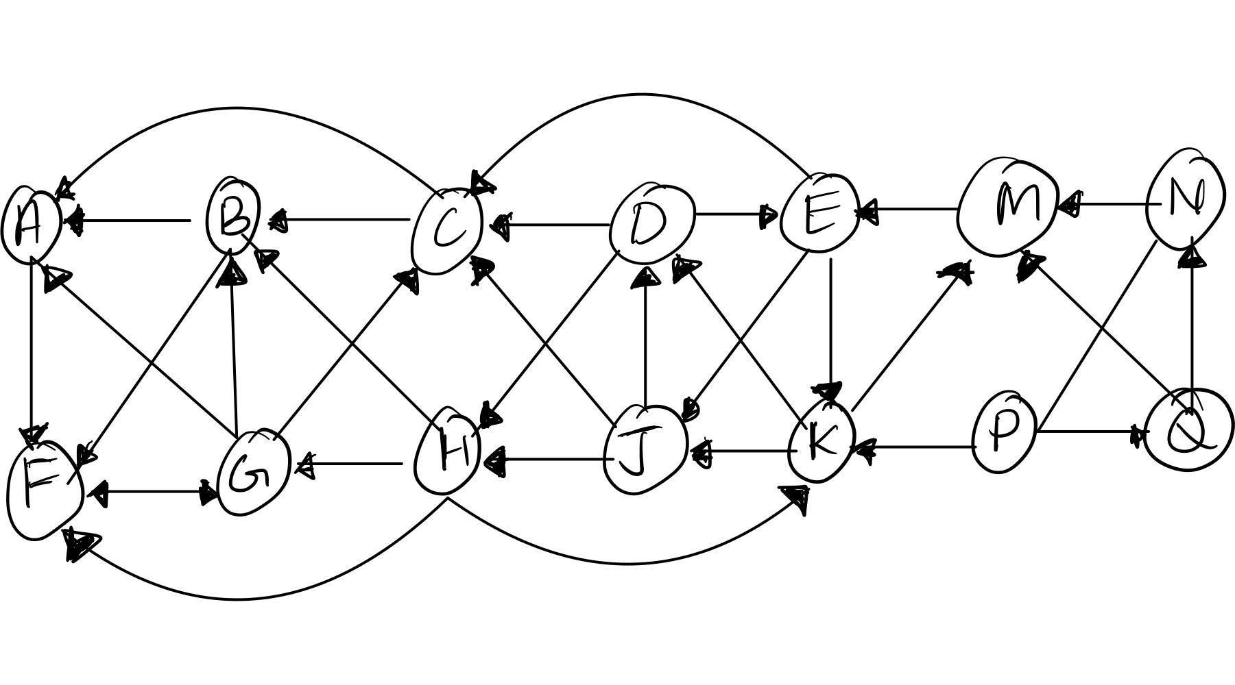
We start DFS using the order of finish time we got in the above table, that is vertex A.
Visit A,
The visit F, then visit G,
Then visit A/B/C
We chose B, then visit B, then from B visit C, then from C, we cant visit any where else.
So SCC[1] = {A,F,G,B,C}

Among the remaining D has highest Finish time,
Visit D, then neighbors are and D, E and H, Visit E, then from E has C, J and K, C is already visited. Visit J.
J has neighbors, C, D, and H, lets visit H.
H has neighbors, B,F,G, now all of these are visited. So, new SCC is
SCC[2] = {D,E,J,H}

Among the remaining, K has highest finish time,
Visit K, it has neighbors, M , D and J. D and J are already done, so
Visit M, M has neighbor E,
Visit E, E has neighbor K,J and C, J and C are already done, so go back to K
SCC[3] = {k,M,E}

Next on the list N,
Visit N, it has neighbors P,
Visit P, it has neighbor, Q,
Visit q, it has neighbor, N, which is already done
So, SCC[4] = {P,Q,N}
The strongly connected components for this graph are.
{A,F,G,B,C}, {D,E,J,H}, { K,M,E}, {P,Q,N}

Question 1) e) :
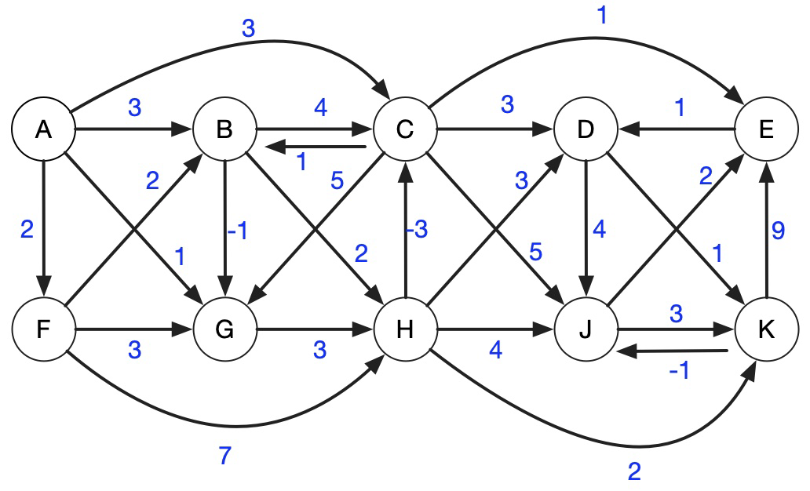-

Initial table:

Vertex | A | B | C | D | E | F | G | J | K | H
Distance | Inf | Inf | Inf | Inf | Inf | Inf | Inf | Inf | Inf | Inf
Parent | Nil | Nil | Nil | Nil | Nil | Nil | Nil | Nil | Nil | Nil
Iteration 1:
Vertex | A | B | C | D | E | F | G | H | J | K
Distance | 0 | 3 | 1 | 5 | 4 | 2 | 1 | 4 | 8 | 7
Parent | Nil | A | H | E | C | A | A | G | C | D

Iteration 2:
C edges:
- C ->B (1+1=2 < 3) ->update B=2 (parent C)
- C ->D (1+3=4 < 5) ->update D=4 (parent C)
- C ->E (1+1=2 < 4) ->update E=2 (parent C)
- C ->G (1+5=6 > 1) — no update
- C ->J (1+5=6 < 8) ->update J=6 (parent C)
- D ->K (4+1=5 < 7) ->update K=5 (parent D)

E edges:
- E ->D (2+1=3 < 4) ->update D=3 (parent E)
- K ->J (5+(-1)=4 < 6) ->update J=4 (parent K)

Vertex | A | B | C | D | E | F | G | H | J | K
Distance | 0 | 2 | 1 | 3 | 2 | 2 | 1 | 4 | 4 | 5
Parent | Nil | C | H | E | C | A | A | G | K | D

Iteration 3:
- D ->K (3+1=4 < 5) ->update K=4 (parent D)
- K ->J (4-1=3 < 4) ->update J=3 (parent K)
Vertex | A | B | C | D | E | F | G | H | J | K
Distance | 0 | 2 | 1 | 3 | 2 | 2 | 1 | 4 | 3 | 4
Parent | Nil | C | H | E | C | A | A | G | K | D

Iteration 4:
No Changes, this is the final iteration.
Vertex | A | B | C | D | E | F | G | H | J | K
Distance | 0 | 2 | 1 | 3 | 2 | 2 | 1 | 4 | 3 | 4
Parent | Nil | C | H | E | C | A | A | G | K | D

Question 2) a)

For one MST:

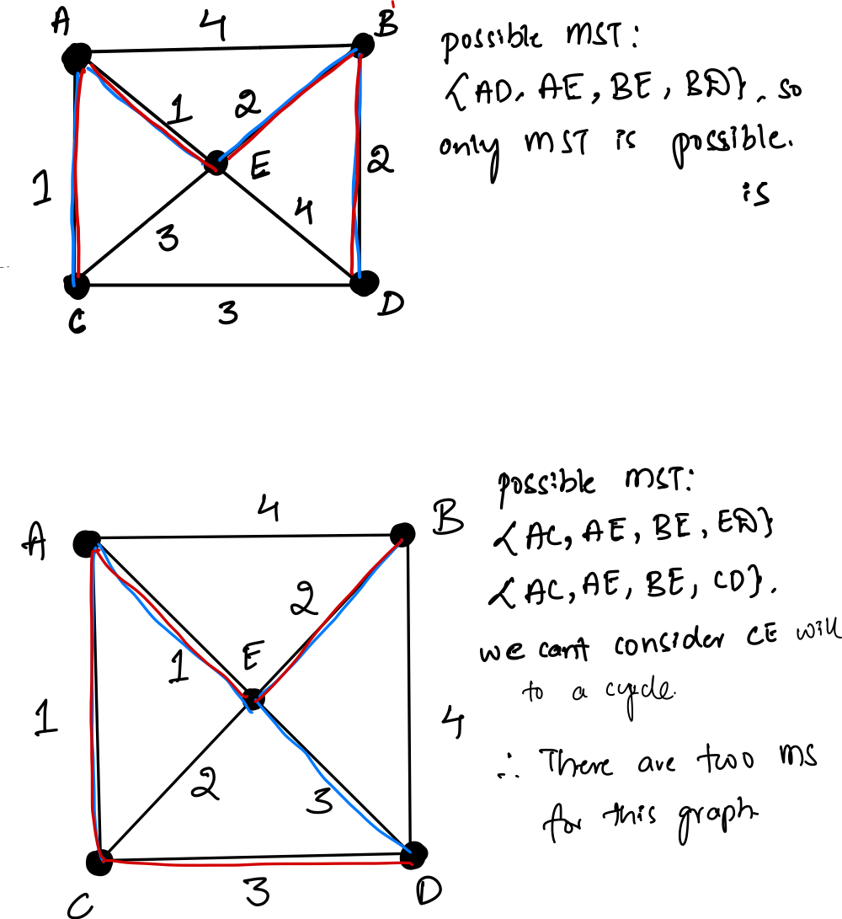

Question 2) b) :
To get the longest path, I will keep track of how long each path goes, and take the maximum from that.
I am modifying the code I have been given in class.

LongPath(u)
Mark u as visited
max_length = 0

For each v in Adj[u]:
If v not visited:
length_v = LongPath(v) + 1
max_length = max(max_length, length_v)

return max_length

Runtime:
Every edge(u,v) is explored once, when the v is still unvisited. This is exactly like normal DFS in terms of runtime. The part keep calculating length and comparing for max length runs in constant time.

So, our runtime will be O(V+E).

For the given graph:
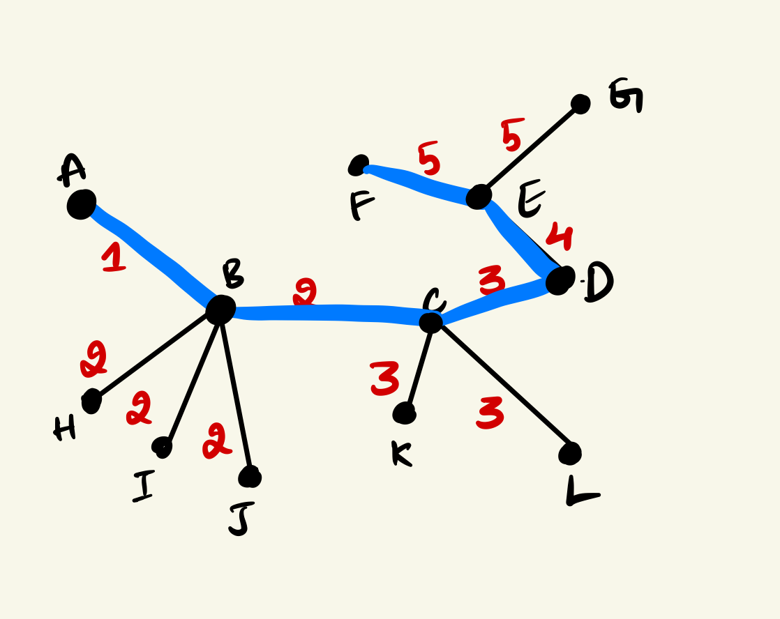

At end of each path, the length is calculated, the maximum along the given blue path is 5.

Question 2)c):

No, I don’t think this solves the problem, since if I process a node once and I have marked it as visited in Dijkstra I am not coming back if there is a longer path that exists.

When I am calculating the shortest path, this can be true, but for longer path, there might be a even longer path.

So that means like in case of shortest path, where we know for sure that, this is the best shortest path we have until this node, for the lonest path , there can be other shorter path that could have led to longer path , we haven’t yet reached, so according to.

When we Extract-Max(Q) for a node u, we assume “I have found the best path to u. Because after Extract-Max, it finalizes u. d, but better paths might still exist later.

Question 2) d):
Note: As per hint given during Office hours, I am not sorting the list (L) of vertices, but creating them from dfs_visit(u) based on when they finish.

Pseudocode:
For DFS visit, and get the list of vertices in decreasing order of finish times;

DFS-Visit(u):
time = time + 1
u.visited = True
u.start = time
for each vertex v in Adj[u]:
if v.visited == False:
v.parent = u
v.distance = u.distance + 1
DFS-Visit(v)
time = time + 1
u.finish = time
L.append(u) # Collect vertex when finished

To transpose the graph:
Transpose(G):
G_T = new empty graph
for each edge (u ->v) in G:
add edge (v ->u) to G_T
return G_T

To do DFS on Transpose and Label components:

DFS-Transpose(G_T, L):
for each vertex u in V:
u.visited = False
u.component_id = None
id = 0
for each u in L:
if u.visited == False:
id = id + 1
DFS-CollectComponent(u, id)

DFS-CollectComponent(u, id):
u.visited = True
u.component_id = id
for each v in Adj[u] in G_T:
if v.visited == False:
DFS-CollectComponent(v, id)

So, now that we know there are three SCC and we need to add exactly three edges:
ConnectComponents(representatives):
# representatives = [one vertex from SCC1, one from SCC2, one from SCC3]
add edge (representatives[0], representatives[1])
add edge (representatives[1], representatives[2])
add edge (representatives[2], representatives[0])

Runtime:
Step 1 | :DFS(G) + DFS-Visit(u) = O(V+E)
Step 2 | : Transpose(G) = O(V + E)
Step 3 | : DFS-Transpose(G_T, L) = O(V + E)
Step 4 | Add 3 edges manually = O(1)

Total Runtime: O(V+E)

Question 3) a):

We have starting loations me (M) , friend (F), pick ups: Pizza (P) and Beer(B), ending: Wedding(W)
Ideally, we should run multiple times the Dijkstra’s and find distance, but as told during office hours , we should avoid running it for V times, since then it becomes really long time to execute.

Then store attributes in each vertex. Calculate total time and pick up minimum.

Step 1:
Which places are Dijkstra’s is being run:
We run it four times:

From M, time from me to any location, stored at d_m[v], shortest distance from m to v.
From F, time from Friend to any location, stored at d_f[v],
From B , time from beer place to any location, stored at d_b[v],
From P, time from pizza place to any location, stored at d_p[v],

Step 2:

Where do I store the attributes:
v.d_m: shortest distance from M
v.d_f: shortest distance from F
v.d_b: shortest distance from B
v.d_p: shortest distance from P

Step 3:
Calculating total time for each option:
Option 1:
You pick up both Beer then Pizza then go to Wedding. Friend drives directly to Wedding.
Important: You must pick up beer first, because problem says pizza must be picked up last.
So your path is: M → B → P → W, Time = d_m[B] + d_b[P] + d_p[W]
Friend’s path: F → W, Time = d_f[W]
Total time: max(d_m[B] + d_b[P] + d_p[W], d_f[W])

Option 2:
You pick up Beer and go to Wedding, Friend picks up Pizza and goes to Wedding.
Your path: M → B → W, Time = d_m[B] + d_b[W]
Friend’s path: F → P → W, Time = d_f[P] + d_p[W]
Total time: max(d_m[B] + d_b[W], d_f[P] + d_p[W])

Option 3:
You pick up Pizza and go to Wedding.
Friend picks up Beer and goes to Wedding.
Your path: M → P → W, Time = d_m[P] + d_p[W]
Friend’s path: F → B → W, Time = d_f[B] + d_b[W]
Total time: max(d_m[P] + d_p[W], d_f[B] + d_b[W])

Step 4:
After computing all those from above , chose among them.
Best = min( option1, option2 , option 3)
Putting the above steps into pseudocode:

minpath(G, M, F, B, P, W):

Run Dijkstra(G, source=M) -> record v.d_m for all vertices
Run Dijkstra(G, source=F) -> record v.d_f for all vertices
Run Dijkstra(G, source=B) -> record v.d_b for all vertices
Run Dijkstra(G, source=P) -> record v.d_p for all vertices

Option1 = max(
M -> B -> P -> W time: d_m[B] + d_b[P] + d_p[W],
F -> W time: d_f[W]
)

Option2 = max(
M -> B -> W time: d_m[B] + d_b[W],
F -> P -> W time: d_f[P] + d_p[W]
)

Option3 = max(
M -> P -> W time: d_m[P] + d_p[W],
F -> B -> W time: d_f[B] + d_b[W]
)

best_time = min(Option1, Option2, Option3)

return best_time

Runtime:

4 Dijkstra’s = 4 * O(ElogV) = O(E log V)
Other options to compute min and best path, run in constant time.

Total runtime T(n) = O(ElogV)

Question 3) b):
I am doing it an way by defining a function that takes in parameter of edge color, as per the hint given during office hours.

Pseudocode:

function alternatingpath(u, incoming_edge_color):
if u == S:
return True # reached the South Pole successfully!

u.visited = incoming_edge_color, # storing the color in visited, as per hint given during office hours.

for each edge (u, v) in Adj[u]:
if edge.color == incoming_edge_color:
continue # must alternate color, so skip same color edge

if v.visited == None or v.visited != edge.color:
if alternatingpath (v, edge.color):
return True

return False

Entry Point Function:

function startalterDFS(N):
for each vertex v in G:
v.visited = None # Clear visited info

for each edge (N, v) in Adj[N]:
if edge.color == green:
if alternatingpath (v, green):
return True

return False

Question 3) c):

So here I am supposed to do store only per node attributes, like u.visited, color etc., I am not making up any new parameters, other than the ones that are in code.

So, we recurse to only neighbors that are white, and during this if we find a node that is already visited then that means we have found a white cycle.
DFS-visit_whitecycle(u):

time = time + 1
u.visited = true
u.start = time

for each v in Adj[u]:
if v.color ≠ white:
continue # we will skip non-white neighbors

if v.visited == false:
v.parent = u
v.distance = u.distance + 1
if DFS-visit_whitecycle (v) == True:
return True # white cycle found in subtree
else if v ≠ u.parent:
# Found back edge to a white visited vertex that is, white cycle
return True

time = time + 1
u.finish = time
return False # Then no white cycle found in this path

Question 3) d):
This question is similar to the last problem we solved in class.
So we are travelling from campground A to B, using water and some edges here weighted as portage.

Note: I am running the Dijkstra’s algorithm here , the one given in class.

Now, for a graph G:
Vertices are campgrounds(n)
Edges are waterways (2n),
And if then e.weight = True, that means e = portage, else its water.

Step by step solution:
- Run Dijkstra’s algorithm on G ignoring portages, from source A.
Let v.d1 be the shortest water-only distance from A to vertex v.
We skip all e where e.portage = True.
- Run Dijkstra’s algorithm on G ignoring portages, from source B.
Let v.d2 be the shortest water only distance from vertex v to B.
Again, ignore all portage edges.

Step 3: Try using each portage edge (u, v) once.
For each portage edge (u, v):
Compute candidate1 = u.d1 + v.d2
Compute candidate2 = v.d1 + u.d2
These represent the total water only distance if you do a single portage between u and v
Ignore the portage edge’s weight (it’s free)

Also consider the case with no portages.
Let waterOnlyPath = B.d1 be the shortest path from A to B using only water (no portages)

Pick the minimum of all possible routes.
Let mindist= min(waterOnlyPath, all candidate1 and candidate2 values)
So, as told we are using a greedy approach , where we have a counter to see how portages are traversed.

Pseudocode:

function mindistance(G, A, B):
# Step 1: Dijkstra from A ignoring portage edges
distFromA = Dijkstra(G, A, ignore_portage=True)

# Step 2: Dijkstra from B ignoring portage edges
distToB = Dijkstra(G, B, ignore_portage=True)

mindist= distFromA[B] # water-only path

# Step 3: Try each portage edge once
for each edge (u, v) in G:
if edge.portage == True:
mindist= min(mindist,
distFromA[u] + distToB[v],
distFromA[v] + distToB[u])

return mindist

Runtime:
Each call to dijkstra’s take O(ElogV), or O(nlogn) , here E= 2n
To check for portages it takes, O(E) = O(n)

Total T(n) = O(nlogn) + O(nlogn) + O(n) = O(nlogn)

